**Project Documentation**

What software Eng SE ?

* state of the art of developing quality software on time and

within budget

* Trade-off between perfection and physical constraints
* SE has to deal with real-world issues
* State of the art!
* Community decides on best practice + life-long education

What are SDLC( software dev life cycle ) & its rules?

* For project development rules & regulation need to be followed for best quality output at defined time limit
* Rules are Software Development Life Cycle – SDLC
* It‘s part of software engineering
* Six rules to be followed…

Project Rules & Regulation (SDLC) Software deve life cycle

6 RULES

1. Requirement
2. Analysis

Requirement analysis

Time requirement

Budget

How many users

Step 1: How many user work on website

* 1. Guest
  2. Customer

* 1. Admin
  2. Employee

Step 2: Define work of each user

* 1. Guest

Website visit

View product categories

View product

Contact us

* 1. Customer

Website visit

View product categories

View product

Contact us

Signup

Login

Manage profile

Add to cart

Make Order

Manage order

Feedback

Logout

* 1. Employee

Signup by admin

Login

Manage product categories

Manage product

Manage Contact us

Manage Customer

View cart report

Manage Order

View Feedback

Logout

* 1. Admin

Login

Manage product categories

Manage product

Manage Contact us

Manage Customer

View cart report

Manage Order

View Feedback

Manage Employee

Logout

Step 3: Define panel by user

Website: Guest / Customer

Employee panel: Employee

Admin Panel: Admin

Step 4: Define Some Diagram

1. Use case Diagram

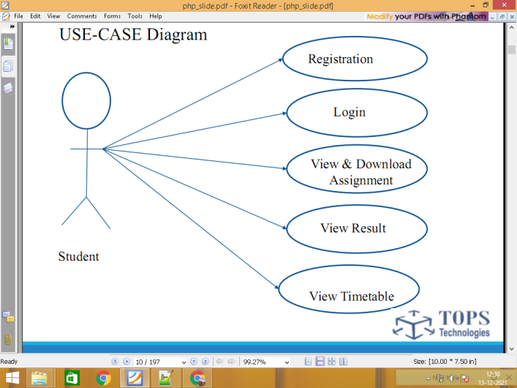

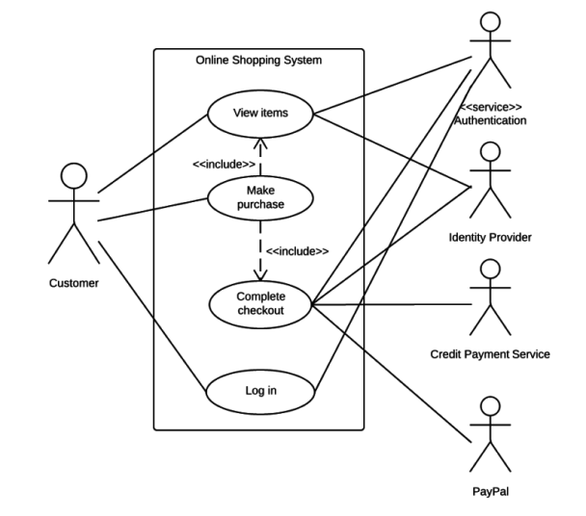

1. DFD Data flow diagram level 0 / 1 / 2

0 level

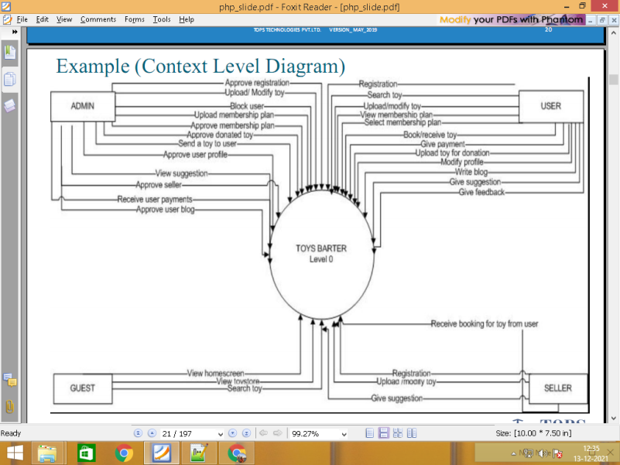

Level 1

\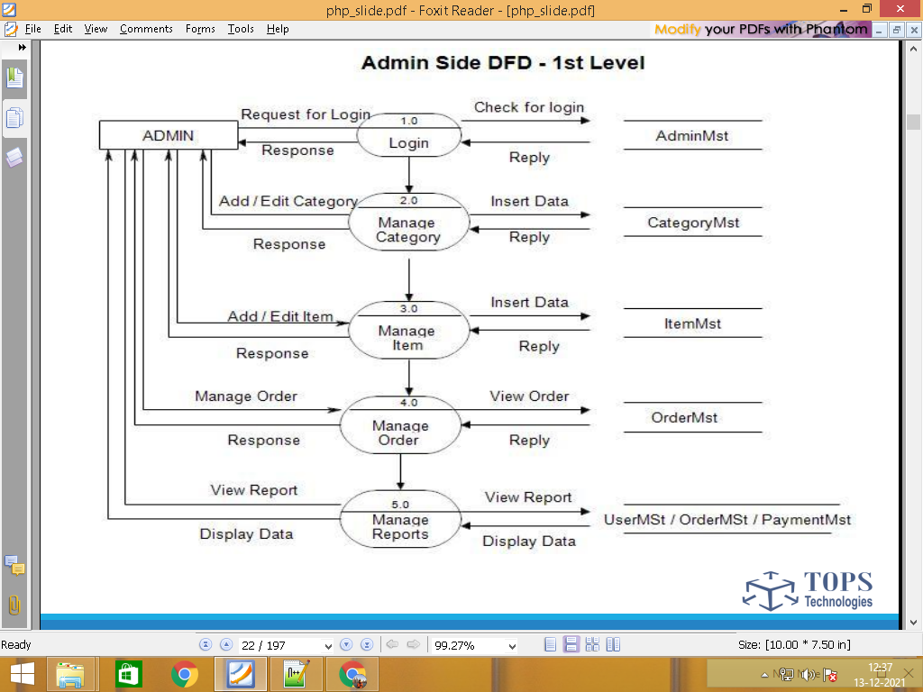

Website visit

Guest View product categories categories.tbl

View product products.tbl

Contact us contacts.tbl

Website visit

View product categories categories.tbl

View product products.tbl

Contact us contacts.tbl

Signup customers.tbl

Customer Login customers.tbl

Manage profile customers.tbl

Add to cart carts.tbl

Make Order orders.tbl

Manage order orders.tbl

Feedback feedbacks.tbl

Logout customers.tbl

Signup by admin employees.tbl

Login employees.tbl

Manage product categories categories.tbl

Manage product products.tbl

Manage Contact us contacts.tbl

Employee Manage Customer customers.tbl

View cart report carts.tbl

Manage Order orders.tbl

View Feedback feedbacks.tbl

Logout employees.tbl

Login admin.tbl

Manage product categories categories.tbl

Manage product products.tbl

Manage Contact us contacts.tbl

Admin Manage Customer customers.tbl

View cart report carts.tbl

Manage Order orders.tbl

View Feedback feedbacks.tbl

Manage Employee employees.tbl

Logout admin.tbl

Step 5: Define Total No. of Table List

admin.tbl

categories.tbl

products.tbl

contacts.tbl

customers.tbl

carts.tbl

orders.tbl

feedbacks.tbl

employees.tbl

Step 6 : Define Each table column / Data Dictionary

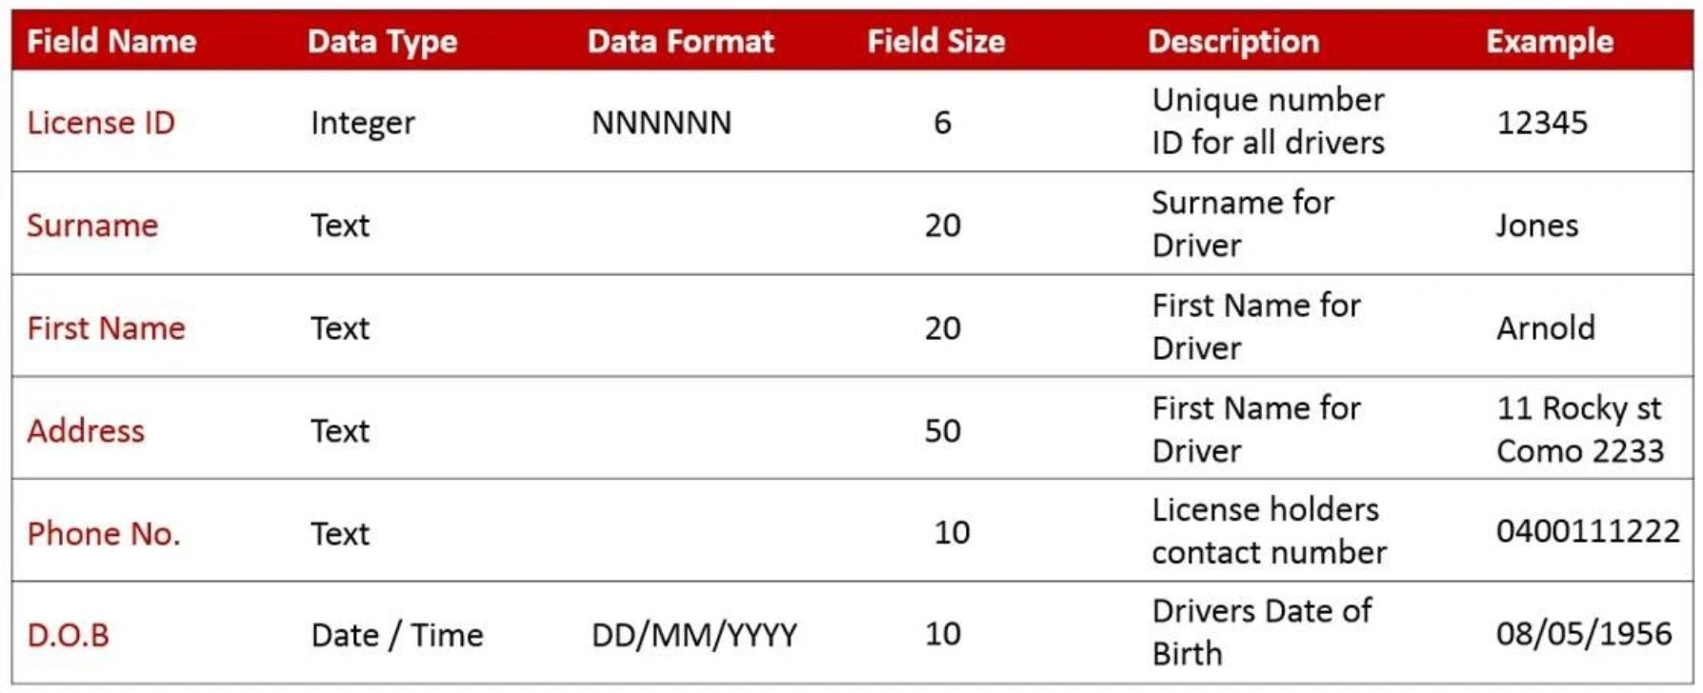

admin.tbl login 2 form

**id pk auto_increement**

name

email

password

**status**

categories.tbl

**id pk auto_increement**

name

image

subcategories form 3 / column 4

**id pk auto_increement**

cate_id fk

sub_catename

sub_cateimage

products.tbl

**id pk auto_increement**

cate_id fk

subcate_id fk

prod_name

short_desc

long_desc

main_price

disc_price

prod_image

**status**

contacts.tbl

**id pk auto_increement**

name

email

comment

customers.tbl signup form 5 / table column 7

**id pk auto_increement**

name

email

password

mobile

image

**status**

carts.tbl

**id pk auto_increement**

prod_id fk

cust_id fk

qty

total_price

orders.tbl

**id pk auto_increement**

cart_id fk

cust_id fk

total_amout

address

state

city

pincode

feedbacks.tbl

**id pk auto_increement**

order_id fk

cust_id fk

comment

employees.tbl

**id pk auto_increement**

name

email

password

**status**

**============================================================**

1. Designing

Database create / website designing

1. Implementation/coding

Data add / update / delete code

1. Testing

Website works without bugs or error

Testing

1. Maintenance

User guide

Installation

After maintenance service

Any changes & updating

================================================